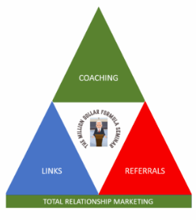

Project 100 Template
Total Relationship Marketing (TRM)
Your Project 100 is your personal foundation network — the people who already know and trust you. List your top 100 contacts, categorize them, and track outreach and LINK opportunities as part of your Total Relationship Marketing system.

# | Name | Relationship | Contact Info | Category | Target Market Connection | Notes / Common Interests | Last Contact | Action Step | LINK Opp. | Follow-Up | Result / Reward

Summary Metrics:
Total Contacts Entered _______
Contacts Contacted _______
LINK Partners Created _______
Introductions Made _______
Successful Outcomes _______
Rewards Given _______

